Unit 5 - More About Forces

# Instructional Goals

1. MF1: I can use Newton’s second law to calculate an unknown force acting on an object.
2. MF2: I can relate the forces acting on an object to its motion using representations such as mathematical expression, motion maps, and free body diagrams.
3. MF3: I can represent friction mathematically and use it to explain the behavior of objects.
4. MF4: I can produce a realistic simulation of a falling object.

# Overview

1. Newton’s 2nd Law

Building off the understanding of Newton’s 1st Law:

* Constant Velocity is the result of ‘Balanced forces’,
* ***Non***-constant Velocity is the result of ‘***Un*-**balanced forces’

Develop a quantitative understanding of the relationship between Unbalanced force and Acceleration

ΣF = m*a

1. Modeling Friction

Determining that Friction is a function of the force between the surface and the object moving across it, but not the area of the contact.

1. Modeling Air Resistance

Recognizing that Air Resistance is a function of the speed of the object moving through the air.

Students will have the opportunity to simulate a situation involving air resistance to deepen their understanding.

# Sequence

1. Lab 1: Modified Atwood’s Machine (Newton’s 2nd Law)
2. Worksheet 1: Newton’s 2nd Law Practice
3. Worksheet 2: Finding Individual Forces
4. Quiz 1: Newton’s 2nd Law
5. Activity 1: Forces during an Elevator Ride (Optional)
6. Worksheet 3: Elevator Ride – Data Analysis
7. Worksheet 4: Elevator Practice
8. Activity 2: Elevator Simulation
9. Worksheet 5: 2-D Problems
10. Quiz 2: Finding Individual Forces
11. Lab 2: Friction Force
12. Worksheet 5: Frictional Force
13. Worksheet 6: Forces and Energy
14. Lab 3: Air Resistance
15. Activity 4: Air Resistance Simulation
16. Activity 5: Drag Race
17. Unit Test

# Supplemental/Optional Activities

1. Activity 0 Pre Exploration—Human dynamics cart (effects of changing ΣF and mass, who pulls harder)
   1. Alternative Exploration – Carts and Acceleration
2. Worksheet – Newton’s 2nd law – 2 body problems

# Instructional Notes

## Special note: System schema

It is important to stress system schemas during the beginning of this unit. Having developed it already in Unit 4, continued stress of the concept of System Schemas will continue to pay dividends. In the development of Newton’s 3rd Law, we contrast the System schema from Unit 4, where we focused on the interactions all happening on ONE system; we now turn our attention to a single interaction BETWEEN systems. We are no longer focusing on MULTIPLE interactions but are now focusing on a single one, but from multiple perspectives.

As we move into Newton’s 2nd Law, we will return our attention to a single object, but all of the interactions with it.

# Lab 1: Modified Atwood’s Machine

There are three different options available for this lab to be completed. Each will be highlighted in these instructional notes.

## Option 1: Force prove

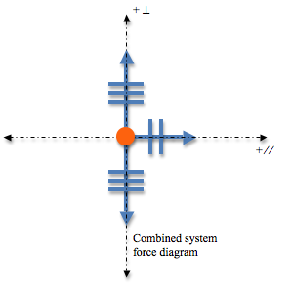

F⊥

FT, s -> c

Fg, E -> c

Force diagram of cart only

A force sensor is placed on the cart, allowing students to easily measure the unbalanced force acting on the cart. The force diagram for the cart is sufficient. A force sensor will directly measure the unbalanced force on the cart if the track is level. Using a wireless force sensor (options are available now from both PASCO Scientific and Vernier will allow students to get data without the complication of wires getting in the way.

|  |  |
| --- | --- |
| Acceleration  (Slope of the velocity vs. time graph) | Unbalanced Force  (Force reading on the sensor) |
|  |  |
|  |  |

## Option 2: “Megadot” system

## Apparatus

* Dynamics Lab Cart
* Dynamics Track
* Pulley
* Hanging masses
* Motion sensor
* String
* Balance

## Pre-lab discussion

* The purpose of this lab is to determine the relationship between acceleration and unbalanced force *for a system*.
* Show the class a cart attached to a string, with a mass hanging over a pulley. The cart and hanging mass will both accelerate.
* Release the cart and ask the students:
  + “What motion do you see for the cart?”
  + “What motion do you see for the hanging mass?”
  + “What conclusion can we draw based on previous investigations?”
* Ask the students what they can measure. The students now have experience with measuring velocity and time for uniformly accelerated motion, so these quantities will occur to them readily. They should also recognize that they can measure the masses of the cart and hanging masses.
* Have the students draw a system schema for the situation, as well as force diagrams for both the cart and hanging masses separately.
* The schema and force diagrams should appear as below:
  + Be sure to identify that the tension forces on both the cart and the hanging masses are the same.
  + Be sure to identify that the tension force is smaller than the force of gravity.

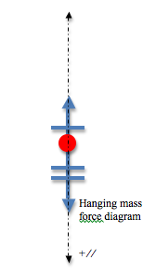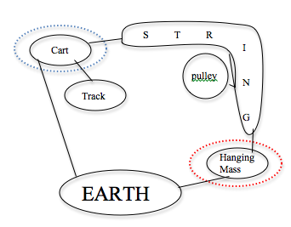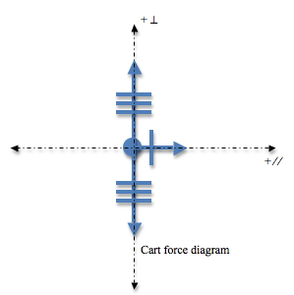

* The key from here is that the directions need to be aligned. Rotate the hanging mass force diagram to align the positive ‘parallel’ directions for both force diagrams. This removes the role of the pulley, as the pulley’s only purpose in this scenario is to redirect the direction of the string. We are in essence ‘straightening’ the string.
* 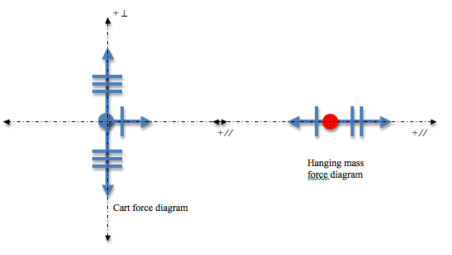Now, since both objects move together ‘as one’, we can consider them as a single system. This should be easier for them to consider after having dealt with the colliding cars in Unit 2 as a single system.

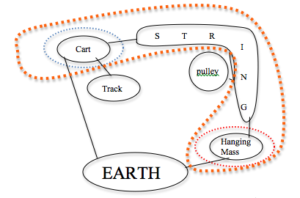

🡨 We identify the system with the ‘orange’ dotted line on both the system schema and the force diagram.

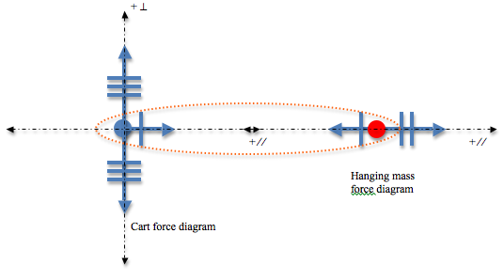

F⊥

FT, s-> c

Fg, E -> hm

Fg, E -> c

FT, s-> hm

* Finally, we draw the system as the ‘megadot’ in the final force diagram and note that the ‘unbalanced’ force in this scenario is the Force of gravity from the Earth acting on the hanging mass, and this force diagram has the same basic structure as the one from Option 1.



F⊥

Fg, E -> hm

Fg, E -> c

|  |  |
| --- | --- |
| Acceleration  (Slope of the velocity vs. time graph) | Unbalanced Force  (Force of gravity on hanging mass) |
|  |  |
|  |  |
|  |  |
|  |  |

## Performance Notes

At this point, we can determine the acceleration of our system using the motion sensor (Slope of velocity vs. time graph) and the unbalanced force by determining the force of the Earth's pull (gravitation) on the hanging mass. We will directly control the unbalanced force, but for our purposes it will serve us better to graph it with the acceleration on the independent (horizontal) axis and unbalanced force on the dependent (vertical) axis.

One final hurdle to this is that the system mass will change, unless the extra mass added to the hanging mass during the lab comes from the ‘cargo’ on the cart. This would allow the system mass to remain the same, and we are merely redistributing it within the system.

Students should be directed to record the amount of the mass of their system (including the cart, extra masses and hanging mass).

## Option 3: Cart on a ramp

## Description: car on inclined trackApparatus

* Dynamics Lab Cart
* Dynamics Track
* Motion sensor
* String
* Force Sensor
* Ring stand
* Track clamp attached to ring stand
* Clamp to attach force sensor to the ring stand

## Pre-lab discussion

Remembering back to the equilibrium demonstrations, we return to the cart on a ramp, being held in place by a string, parallel to the ramp. In this scenario, a force sensor (aligned parallel to the track) is holding the string that keeps the cart in place – recording the force required. When the string is loosed, the cart rolls down the ramp, accelerating as it goes.

The force sensor records the amount of force required to ‘balance’ the forces on the cart. Removing the string, there is now an ‘unbalanced’ amount of force which acts on the cart, equal to the amount recorded by the force sensor. By changing the angle of the ramp, we can change the amount of force. We can use a motion sensor to determine the acceleration, as before with options 1 and 2.

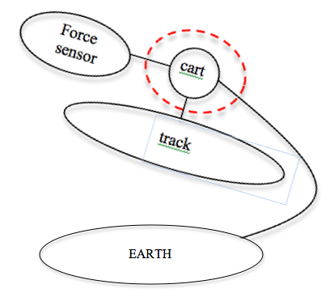The pre-lab discussion should still go through the system schema process, as well as the force diagram – students should have completed QUALITATIVE force diagrams for inclines at a minimum for this option to be cognitively meaningful and accessible for students to focus on Newton’s 2nd Law.

# The force diagram to the right shows the situation in equilibrium. When the string is removed, the force sensor no longer holds the cart in equilibrium, and so the amount of force that is causing this ‘unbalance’ must be the same as the amount the force sensor was supplying while it was acting.

Fg, E 🡪 c

F⊥, T 🡪 c

FT, FS 🡪 c

Vary the amount of ‘unbalanced’ force acting on the cart, by varying the angle of the track. Use a motion sensor at the top of the track to determine the acceleration and graph this ‘backwards’ as described in the previous options.

|  |  |
| --- | --- |
| Acceleration  (Slope of the velocity vs. time graph) | Unbalanced Force  (Force as measured by the force sensor - mean) |
|  |  |
|  |  |
|  |  |
|  |  |

# *WORD OF CAUTION:*

# *This option is a bit less expensive than option 1, and certainly less complicated than option 2. But, this option has its potential pitfalls in that if the students do not understand the force diagram for an object on an incline on a qualitative level, then this lab will not result in a clear understanding of Newton’s 2nd Law.*

## Post-lab discussion

Once the data is collected, the graph produced will appear something

like this:

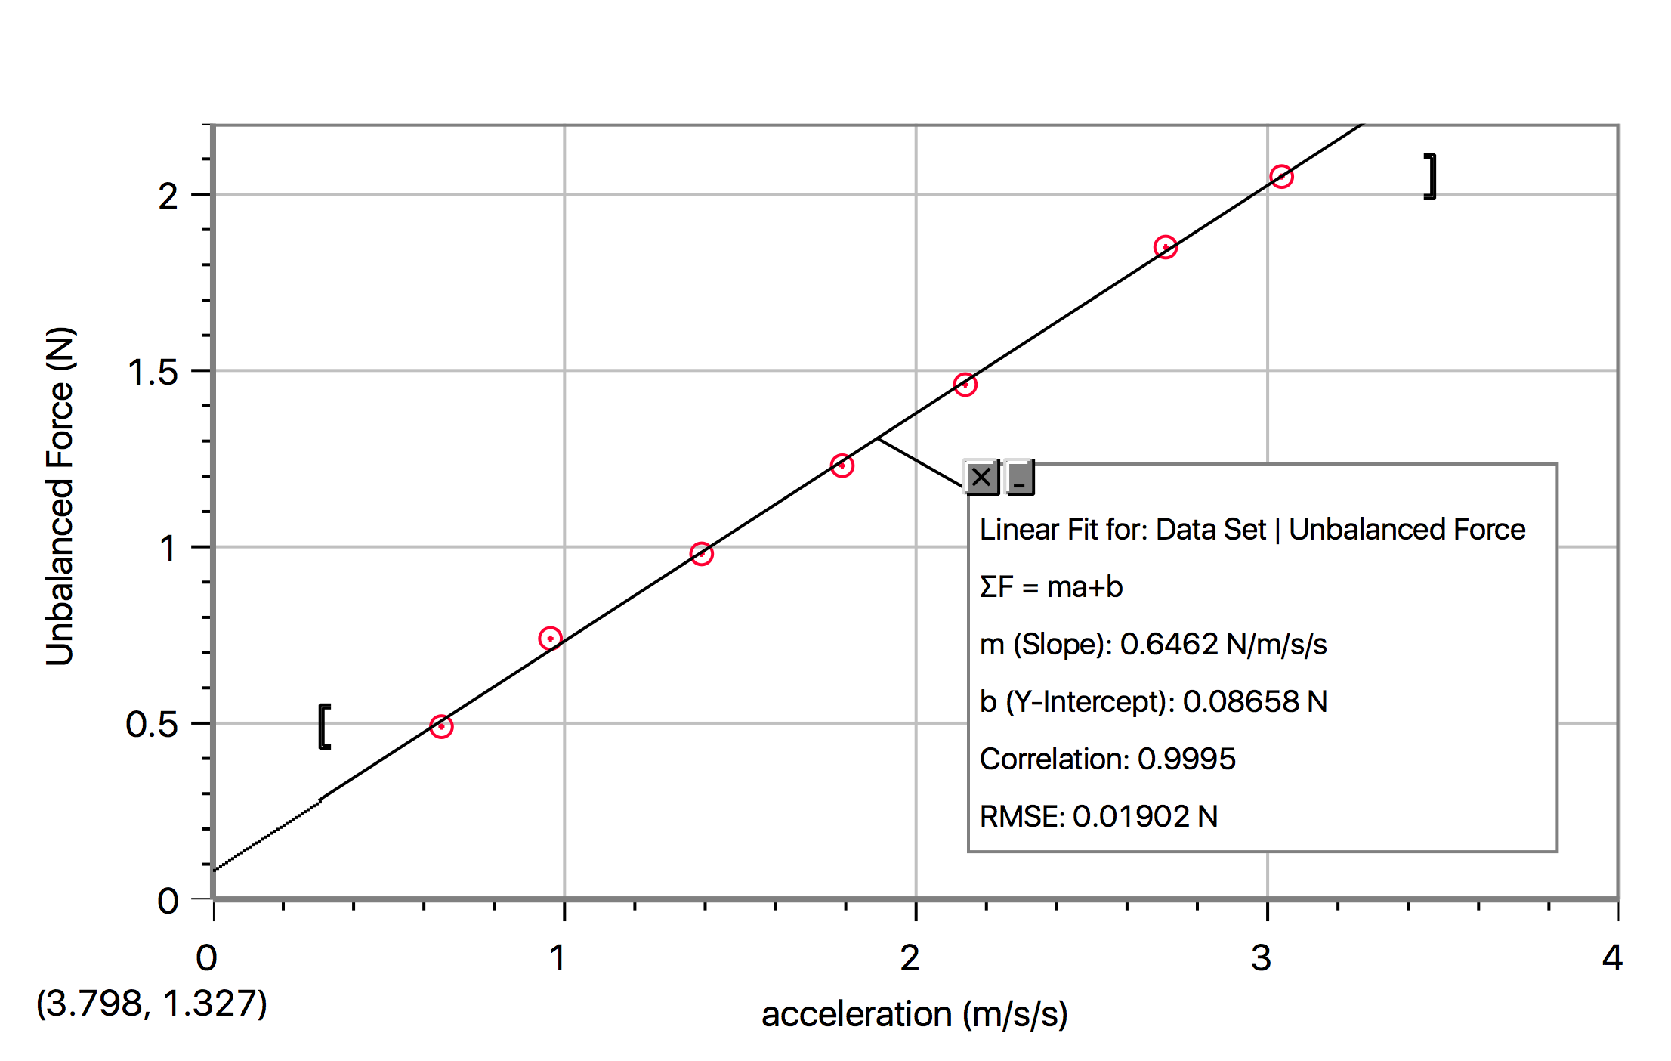

(Optional discussion topic: What does the intercept represent? It is small, but it is not zero. It is insignificant, but does have meaning. *Ultimately, this represents the frictional force on the cart, which was assumed to be zero.)*

Writing out the equation for this data, the equation is: ΣF = (slope)*a. Evaluating the slope’s units, we find that the slope seems to be somehow related to mass (as the units simplify to represent kilograms).

Evaluating the value of the slope, we find that the number is very close to the value of the system’s mass. Substituting ‘mass’ for the slope, the generalized equation becomes:

**ΣF = m*a** 🡨 “Newton’s 2nd Law”!

## Instructional note

Regardless of the option you decide to do, proper prep must be done ahead of time to prepare the students for the conceptual challenge this lab will require. Students must have a strong understanding of either ‘megadot’ systems or qualitative force diagrams of forces on angles, specifically inclines in order for this lab to be meaningful and useful.

# Worksheet 1: Newton’s 2nd Law Practice

Students will have the opportunity to practice utilizing Newton’s 2nd Law.

# Worksheet 2: Finding Individual Forces

Students will have the opportunity to practice utilizing Newton’s 2nd Law to find an individual force in a given situation.

# Quiz 1: Newton’s 2nd Law

Review of the Force of Gravity (aka Weight) equation, as well as basic usage of Newton’s 2nd Law.

# Activity 1: Forces During an Elevator Ride (Optional)

The notion that the perpendicular (aka, normal) force is always equal to the force of gravity is a deeply rooted idea. This needs to be unmasked as an erroneous conception. This is only possible through actively confronting the idea in a lab setting. Even after confronting it, we will often see this crop back up when forces act on angles; objects are placed on a ramp, etc. This idea is not easily quenched in the minds of students and efforts must be made to continually cycled back to this activity in the minds of the students.

## Apparatus

* Access to an elevator
* Bathroom scale or force plate
* Spring scale (with portable ring stand placed on the floor of the elevator)
* Mass set
* Video capture device

## Pre-lab discussion

Discuss the motion of an elevator from the bottom of a building to the top. Students will each have an opportunity to ride the elevator with a force plate, bathroom scale, or spring scale.

## Performance notes

While standing on the force plate or bathroom scale, or while watching closely the spring scale, students will ride the elevator from the top floor to the bottom and record their data. They will then ride the elevator all the way back down and record that data as well. (Using a video camera on their phones or an ipad is a good way to collect data from the spring scale.)

## Post-lab discussion

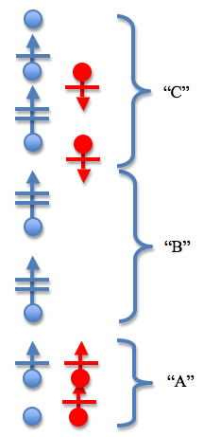Students should begin by illustrating their force data while riding up on the elevator as a graph and include a note of approximately where in the building they were during the ride (Aka, bottom floor, middle of the building, or ‘nearing’ the top). These points can be referred to as ‘A’, ‘B’, and ‘C’, for the sake of simplicity for the continued discussion.

After discussing what their data is showing about the force the meter provided to them or the mass set, have students draw a motion map for the situation on their whiteboard. The students should identify three distinct sections of the motion: Speeding up while moving up, moving up at a constant velocity and slowing down while moving up. Identify these sections as “A”, “B”, and “C”.

Continued discussion about what the motion map is describing to them about their forces should be undertaken at this time. Clearly the forces are not ‘balanced’ the entire time. A reason for this must exist!

Students should then be directed to draw a force diagram for each of the 3 situations for “A”, “B”, and “C”.

This establishes that the perpendicular force changes during the course of the ride. Students should then ‘re-ride’ the elevator and focus on HOW THEY FEEL during each section of the motion. Do they feel ‘normal’, ‘heavier than normal’ or ‘lighter than normal’? Students should then look for a link about ‘how they feel’ and the force diagrams they have drawn.

Finally, extend them to the hypothetical situation of what they would ‘feel’ if the elevator cable were to break while they were on the elevator.

If no elevator is available, please feel free to use the video found in the Supplemental Files “Elevator Ride with Graphs”. This will not give them the same experience, but it will give them a foundation to test on their own at the local mall, etc. in the future.

## Alternative activity

Using a force sensor and pulley system, slowly raise an object at ‘constant’ speed. Attaching the string to a constant velocity car would work well.

# Worksheet 3: Elevator Ride – Data Analysis

This worksheet offers students the opportunity to analyze data from an elevator ride and interpret it to determine the motion that is occurring at the various times. This will also give students the opportunity to reason beyond the obvious plug and chug.

# Worksheet 4: Elevator Problems

This worksheet provides students extra practice with vertical acceleration.

# Activity 2: Elevator Simulation

This simulation allows students to test their understanding of the forces acting on a person while in an elevator. They input what they think the value of gravity and the normal force should be and see whether or not the person moves with the elevator. The student simulation can be found here: <https://tinyurl.com/yctn39cr>.

# Worksheet 5: 2D Problems

This worksheet expands the concept to include forces acting in both horizontal and vertical forces.

# Quiz 2: Finding Individual Forces

Finding individual forces, etc.

# Lab 2: Friction Force

Some teachers may feel the need or be inclined to go through friction with a bit more detail than the treatment we have given to it up to this point. This is not necessary in the investigation of Newton’s 2nd Law, but it is a valuable exercise if you have the time to do it and your students are capable of a little bit extra.

## Apparatus

* Wooden Blocks with a hook attached
* Force Sensor
* String
* Rubber band
* Mass set

## Pre-lab discussion

* The purpose of this lab is to investigate the relationship between perpendicular force and friction force, developing the concept of the coefficient of friction.
* Start the activity with students observing the wooden block as it moves across a table. The block should be pulled at a constant velocity (or as close as possible) by a string or rubber band attached to the hook embedded into the wooden block.
* Students should draw a system schema and force diagram for this scenario.
* Attention must be drawn to the fact that there are TWO lines on the system schema between the table/surface and the wooden block (system). This begs the question: “Is there a relationship between these two forces?”
* Additional investigations that could be carried out: surface area and type of surface
* If the object is moving at a constant velocity, determining the amount of friction is as easy as measuring the amount of force applied along the string. And the perpendicular force is as easy as determining the force of gravity, assuming the activity is conducted on a horizontal surface.

Before moving into the lab to determine the amount of the friction, a live graph should be demonstrated by the teacher during the complete pull. The graph should look very similar to the one below, without the annotations.

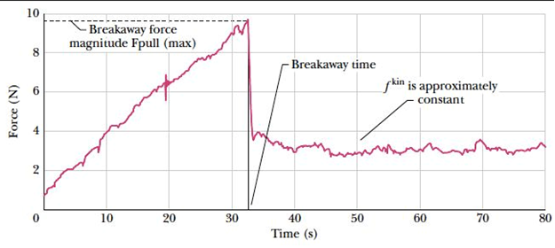

This leads to some obvious questions:

* Which force value should we record?
* There are clearly two sections to the force graph, what do these sections represent?
  + Students should be directed to consider the motion of the block during that time.

The annotation on the graph above:

* The static friction force that we want to record is the MAXIMUM value.
* The kinetic friction force that we want is the MEAN value of the ‘flat’ area.

## Performance notes

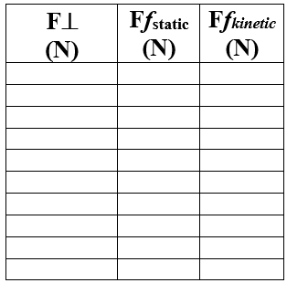It should be stressed to the students that they need to ensure that they get a graph VERY similar to the example graph above in order to record the data.

Often after the pre-lab demonstration and discussion, there may be very little time left in the period that day to collect data. Even so, it would be beneficial to allow the students the opportunity to complete a few trials just to familiarize themselves with the process.

The perpendicular force can be changed by adding more mass to the wooden block.

The data table should match what is shown to the right. BOTH the Static and Kinetic Friction should be graphed against the perpendicular force.

## Screen Shot 2016-07-29 at 6Post-lab discussion

After completing the data collection, the graph matches what is shown to the right.

It should be noted that the slope for the kinetic friction force is greater than the static friction force.

It should be noted that the static friction force graphed is the MAXIMUM, not the actual friction value for all static situations.

**Kinetic friction:** Ffk  = μk F⊥

**Static friction:**  Ffs  ≤ μs F⊥

Please note the equation for the Static friction is an inequality, not an equal sign. The static friction can be ANY magnitude UP TO the maximum value. This is similar to the perpendicular force, which can be any number, up to the breaking point of the surface. Thin ice is a good example to discuss regarding the limit to the normal force.

# Worksheet 6: Frictional Force

Students practice calculating Friction force, based on the expressions just investigated.

# Worksheet 7: Forces and Energy

The goal of this worksheet is to dig a little deeper into Newton’s 2nd Law, tie it together with energy and look at the implications. This worksheet prepares students to understand the Work-Energy Theorem, setting them up for the Quantitative Energy Unit.

# Lab 3: Air Resistance

## Apparatus

* Paper coffee filters
* Camera and video analysis software (LoggerPro, VideoPhysics app)

## Pre-lab discussion

The purpose of this experiment is to develop a mathematical representation to describe the effect of air resistance on the motion of a falling object.

* Hold a coffee filter in the air and drop it. Ask students to describe the motion of the filter. Most will state that it appears to float, that it does not continue to accelerate toward the floor.
* Ask students to create a force diagram for the coffee filter. They should state that two forces act on the filter: gravity and air resistance. At some point these two forces should be equal in magnitude. We already know that when the sum of the forces on an object is zero, that object experiences no change in motion.
* Ask students what evidence we will need to determine the filter is not accelerating. Acceptable evidence will include a linear position vs time graph, a slope of zero on a velocity vs time graph and equal intervals on a motion map. All three of these representations are available through video analysis.
* If your students have not yet used video analysis software, it will be important to model the process. See the performance notes below for suggestions.

## Performance notes

* Students will film the motion of the coffee filter as it falls. The camera must remain stationary. Placing a meter stick in the background of the video will allow students to set scale on the video.
* An alternative would be to have students use the vertical position of the coffee filter and the video timestamp to collect data points.
* Groups will generate graphs of **vertical position vs time.**
* As an extension, groups can obtain data using different numbers of coffee filters. A larger mass will result in a higher terminal velocity.



## Post-lab discussion

* The graph will show an increasing speed for a short period of time followed by a period of constant velocity. Students can interpret each portion of the graph as evidence of the behavior of the falling coffee filter.
* Students can compare the slopes of the linear portion to determine a pattern. Those groups that used a larger number of filters will see a larger negative slope as the terminal velocity is higher.
* An additional graph of **Fg vs vt (terminal velocity)** can be constructed using class data to show a direct linear relationship. This relationship will be used in the Pyret simulation that follows.

# Activity 4: Air Resistance Simulation

This activity as students completing a simulation of the falling coffee filters they explored in Lab 3. This will be the first simulation with non-constant acceleration, so students will need to write a new function called find-a. Notice that this function is not called next-a. That is because the function does not use the acceleration at the current tick to calculate the acceleration in the next tick. Instead, it uses the velocity at the current tick to calculate the acceleration at that same tick. Students should be encouraged to use the values they found in Lab 3 to complete this simulation, then compare the simulated results to their experimental results. Student code can be found here: <https://tinyurl.com/ych27xjq>

In question 1, make sure that students choose two frames where the coffee filter is still accelerating and one frame where it has reached terminal velocity.

# Activity 5: Drag Race

## Part I

Students use 'keys' to operate the 'thrust' of the car, and a separate 'key' to deploy the parachute at the end of the race. Students will start to apply the ‘thrust’ once the light turns green… they will maintain the thrust throughout the motion, and must deploy the parachute after the car crosses the finish line.

## Student goal

The students will want the shortest time to cross the finish line AND the shortest distance before stopping. Composite score is determined as the product of the time to cross the finish line and the stopping distance.

## Instructional goal

Students must recognize the changing forces acting on the drag racer during the different stages of the motion. They should code their find-a function **in terms of the forces acting on the car**.

|  |  |
| --- | --- |
| Sample student code: | **fun** find-a(thrust, drag, chute):        (thrust - drag - chute) / mass  **end** |

Student code found here: <https://tinyurl.com/y7noxdlr>

## Part II

Here students get the computer to operate the Thrust and the Chute deployment... So now, the student responsibilities for programming are ramped up significantly.

In order to get the best possible 'composite' score... they need the computer to 'hit the gas' at the appropriate time... and the computer to STOP using the gas pedal and release the chute at the right time.

Student code found here: <https://tinyurl.com/ybp9kpqv>

## Goal

The goal remains to get the lowest possible composite score. The composite score remains the product of the time to the finish line multiplied by the stopping distance.

## Student programming responsibility in Part II

* f-drag (a function of speed)
* f-chute (a function of speed)
* find-a (a function of ‘light’, position, drag, chute)

**Sample student codes:**

|  |  |
| --- | --- |
| The drag force is a function of the speed of the car.  (“b” represents the constant of proportionality.) | **fun** f-drag(v):        b * v  **end** |
| The chute (parachute) force is also a function of the speed of the car.  (“c” represents the constant of proportionality for the chute) | **fun** f-chute(v):        c * v  **end** |
| The find-a function is a function of:   * The light condition – must be ‘green’ for the thrust to be applied. * The Drag force – the drag force is a function of v…   The Chute force – the Chute force is also a function of v…, and ONLY shows up when the car is at (or beyond) the finish line. | **fun** find-a(light, x, drag, chute):  **if** (light == "red") or (light == "yellow")            0  **else if** (x < 1000) and (light == "green")           (thrust - drag) / mass  **else if** x >= 1000:           -1 * (drag + chute) / mass  **end**  **end** |

* *NOTE:* MAX-THRUST *is not a variable of this activity, it is a constant parameter of the situation.*
* *Students may choose to put the conditionals into the force functions rather than the* find-a *function. It is up to you to decide whether or not that is acceptable.*

The fact that thrust was in input of find-a during Part I but not during Part II is a good way to see if students really understand how to determine the inputs to a function. Because the thrust was being toggled behind the scene in Part I, there were two possible values it could have, and thus it needed to be an input to the function. In Part II, the students decide what the value of the thrust force will be within the body of the function, it does not need to be an input.

## Coding skills necessary

* Conditionals (applying the proper forces at the appropriate times to determine the acceleration)

# Supplemental/Optional Activities

# Activity 0: Human Dynamics Cart

## Apparatus

* 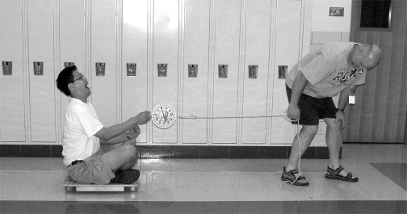Human Dynamics Cart, rolling chair or cart (See diagram below)
* Heavy-duty spring scale
* Stopwatch

## Goal

The purpose of this activity is to provide a common physical experience for students to commence their study of balanced and unbalanced forces on systems.

## Pre-activity discussion

Divide the class into groups of three students. Each group should be comprised of a small, medium and large student.

Discuss with the class what variables they think would affect the acceleration of the cart. Make a list of these on the board. When the students have an idea of what variables might affect the acceleration of the cart, have them go in the hall and test these variables.

## Activity performance notes

You will need to provide students with spring scales so that they can make rough measurements of force. They will also need stopwatches in order to get an idea whether the acceleration of the cart is increasing or decreasing as the pulling force on or mass of the system is changed. The stopwatch and spring scale are not meant to take quantitative measurements at this point, they are only for reference so that students can gauge the effects of their changes on acceleration.

## Post-activity discussion

Ask the students to devise qualitative rules that describe how mass and net force affect the acceleration of the cart. Allow each lab group to whiteboard their findings and explain to the class the rules that they have discovered during the exploratory activity.